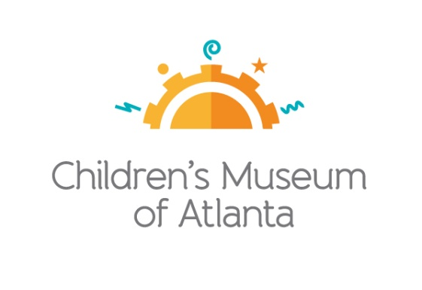
CONTACT
Jennifer Walker
BRAVE Public Relations
404.233.3993
jwalker@emailbrave.com

*MEDIA ADVISORY*
Children’s Museum of Atlanta to host TinyCON®, September 5-6
Fourth-annual celebration of all things fantasy, fiction, gaming and more!

ATLANTA (August XX, 2020) – Calling all tiny adventurers! Children’s Museum of Atlanta will once again host TinyCON®, a two-day celebration of kids’ favorite comics, games, fantasy books and more, Saturday, September 5 and Sunday, September 6. Throughout Labor Day Weekend, kids can channel their inner superhero with arts and crafts at the Avengers Tower; experiment with chemical reactions to create and dissolve their own DIY Pokémon pokeballs; and participate in Jedi training! Costumes are welcome and families are encouraged to purchase tickets in advance. During TinyCON®, the Museum will continue to practice COVID-19 safety measures, including operating in a session format with cleaning breaks in-between, adhering to social distancing guidelines and wearing face masks.

WHAT: TinyCON®
Celebrate Labor Day weekend with a two-day celebration of fantasy, science fiction, comics, and gaming… for little ones!

WHEN: Saturday, September 5 and Sunday, September 6

Creativity Café: Avengers Tower
Session A (9:45-11:15 a.m.), Session B (12:45-2:15 p.m.),
Session C (3:45-5:15 p.m.)

Science Bar: Pokémon Slime Time + Fizzing Poké Balls
Session A (9:45-11:15 a.m.), Session B (12:45-2:15 p.m.),
Session C (3:45-5:15 p.m.)

Morph: Kyber Crystals + Lightsaber Making
Session A (9:30-11:15 a.m.), Session B (12:30-2:15 p.m.),
Session C (3:30-5:15 p.m.)

CMA On Stage: Jedi Training
Session A (10-11 a.m.), Session B (1-2 p.m.), Session C (4-5 p.m.)

WHERE: Children’s Museum of Atlanta
275 Centennial Olympic Park Drive, NW
Atlanta, GA 30313

HOW: Due to the popularity of TinyCON®, guests are encouraged to purchase tickets online in advance for guaranteed entry and the best value. For additional details and to purchase tickets, visit childrensmuseumatlanta.org.

For more information or to support Children's Museum of Atlanta,
visit childrensmuseumatlanta.org or call 404.659.KIDS [5437]

###

